Lesson 13: The Sun, the Earth and the Moon.
E. Write short notes.
1. How is energy produced in the sun?
Ans: The sun is made up of gases that react vigorously. This results in the release of large amount of heat and light energy.
2. What is the middle layer of the Earth called? What is it made of?
Ans: The middle layer of the earth is called mantle. It is made up of hot molten rock.
3. How were the craters formed on the surface of the moon?
Ans: Most of the craters on the moon were formed when meteors (big rocks from space) struck it millions of years ago.
4. What do you understand by new Moon?
Ans: The face of the moon in which the side facing the Earth gets no sunlight is called the new moon.

F. Answer these question
1. Explain the internal structure of the Earth with the help of a label diagram
Ans: The outer layer of the earth is called the crust. The central region is called the core. The middle layer between the crust on the core is called the mantle.
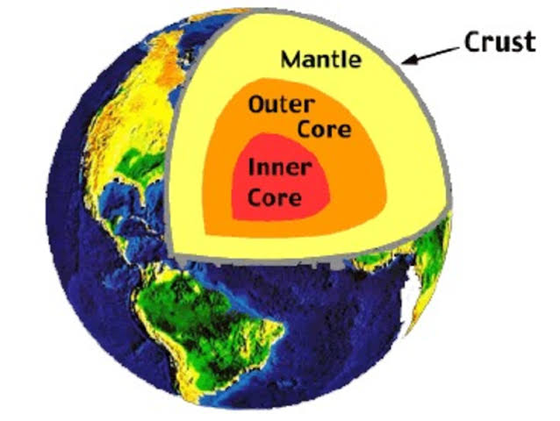

2. What are the different phases of the moon? How are they formed?
Ans: The face of the moon in which the entire side of the moon facing the earth gets sunlight is called a full moon
- After 3 - 4 days, we can see a portion of the moon which is slightly smaller than the size of a full moon. This is called the gibbous moon.
- After a week from seeing the full moon, we see half of the moon. This is the Half Moon phase.
- After 3 - 4 more days or 11 - 12 days after the full moon, we can see a bow shaped curved moon. This is called the Crescent moon.
- Thereafter, 2 - 3 days later or 14 – 15 days after the full moon, we cannot see the moon at all. This phase of a moon in which the side facing the Earth gets no sunlight is called the new moon.
- After the new Moon phase the bright portion of the moon increase. We again see the full moon after 14 - 15 days.
3. What is an eclipse? How does a lunar eclipse occur? Explained with the label diagram.
Ans: During their movement, sometimes, the Sun, the Moon, the Earth come in a straight line. In such situation, the Moon or the Earth cast their shadows on the other. This results in blocking the view of the Sun or the Moon for sometime. When we cannot see the Sun or the Moon for such reasons, we call it an eclipse.
When the Earth comes between the Sun and the Moon, it blocks the sunlight from reaching the Moon surface. Thus, a shadow of the Earth falls on the Moon and we cannot see the shaded part of the Moon. This is called lunar eclipse. During a partial lunar eclipse, only a portion of the Moon is covered by the Earth shadow. In a total lunar eclipse, the Moon is completely covered by the Earth shadow.

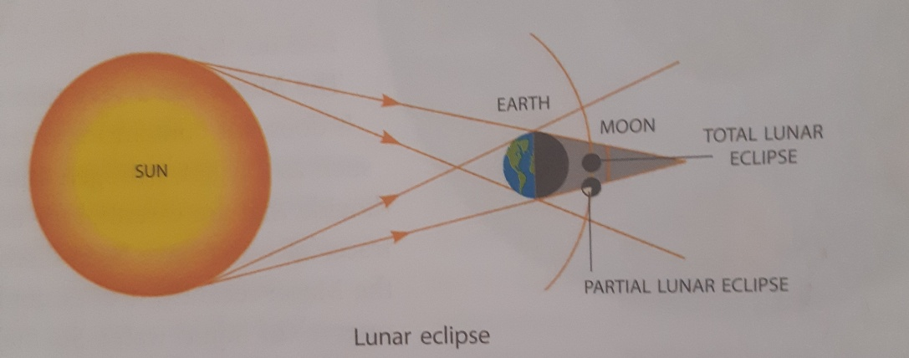

*complete the think and answer
* complete the do and learn and Science club activity
*Make a video on formation of a solar eclipse at home

